CS 504 Software Engineering

HOS08A – CI/CD – Khushiben Patel

**Creation of a Static Website**

Login to the GitHub account and click on New to create repository.

Enter the details as shown in the following picture and create the repository.

Clone the repository and add an index.html file with the following tag.

<h1>Hello<h1>

Push index.html file to the GitHub repository.

Click On "Go to the Azure portal" and sign in with your Microsoft account.

In the Search bar, enter "Static." Click on static Web Apps

Select Static Web Apps.

Click on the Review + create button.

Click on Create.

Click on "Go to resource".

Copy the URL and open it in a new tab.

In Visual Studio Code, open a new terminal, and type the following command.

git checkout -b development

The following should appear.

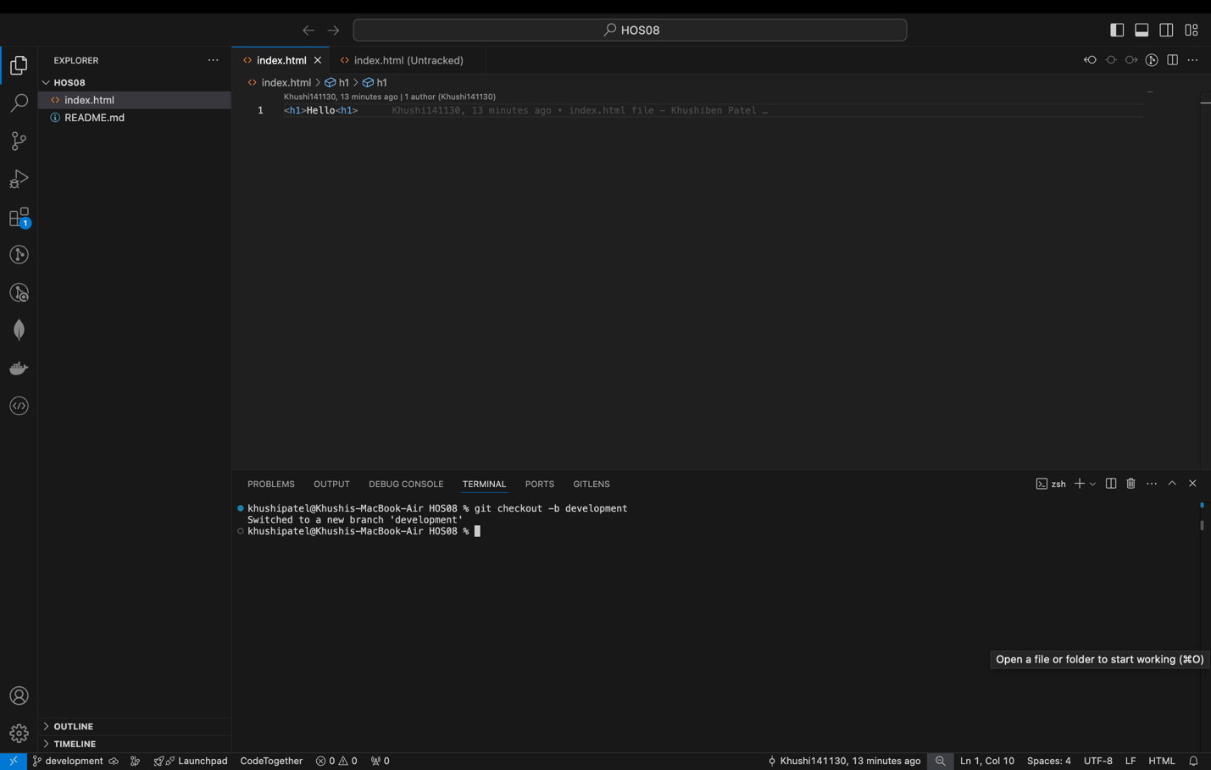

The following should appear.



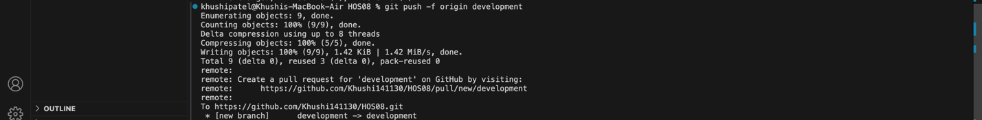

Go to git hub account and click on Pull request.

Click on Compare & pull request à Create pull request à Merge pull request à Confirm the merge.

Click on Actions and wait till all the jobs are completed.

Go to Azure Portal à Static Web Apps à Select HOS08

Copy the URL and open it in the new

Go to Azure Portal à Static Web Apps à Select HOS08

Click on Delete

